**CS121 – Principles of Computer Science**

**PROJECT-1**

Database Examples (Not all entries are captured within the image): 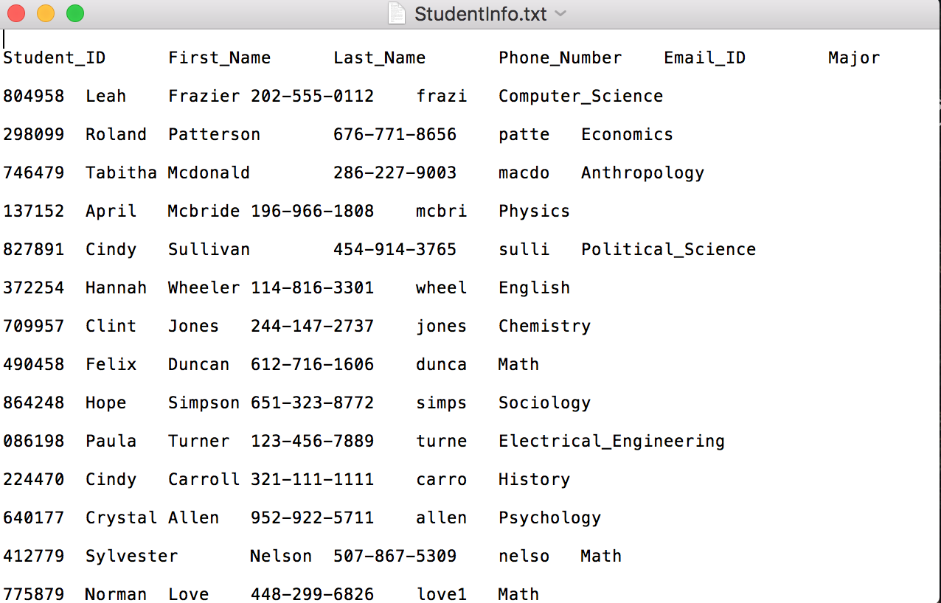

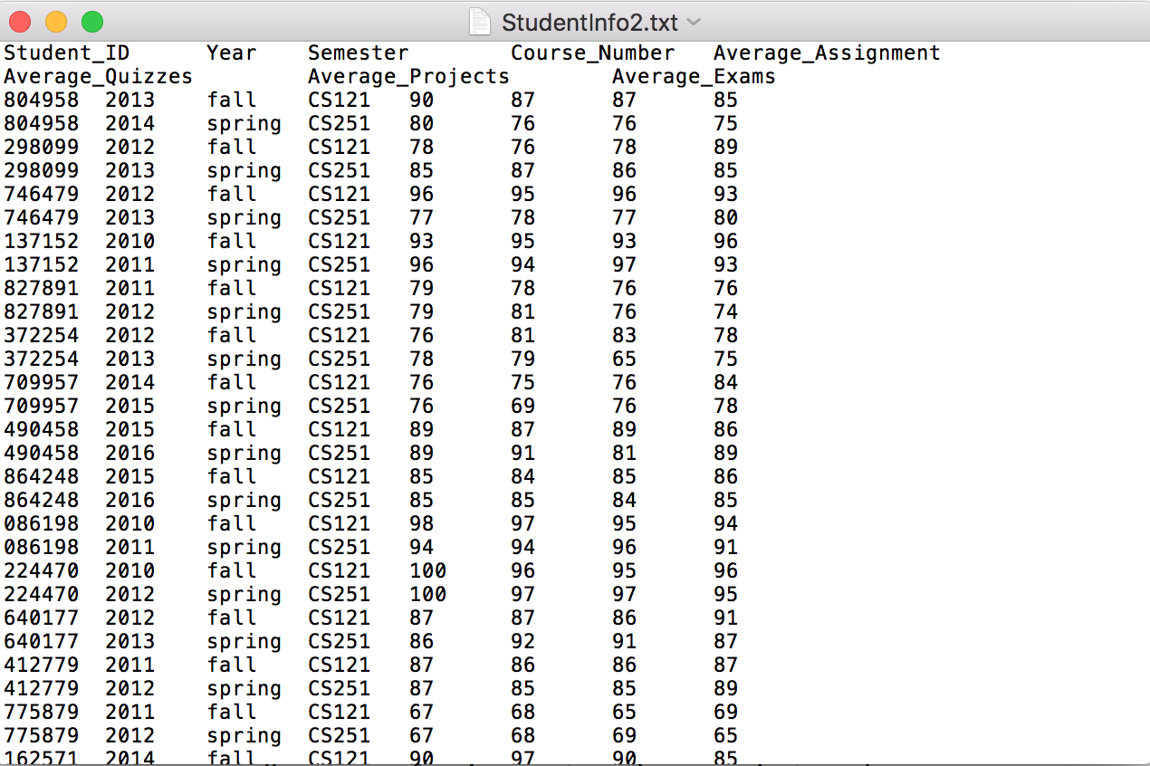

Exercise 1: LIST OF LISTS

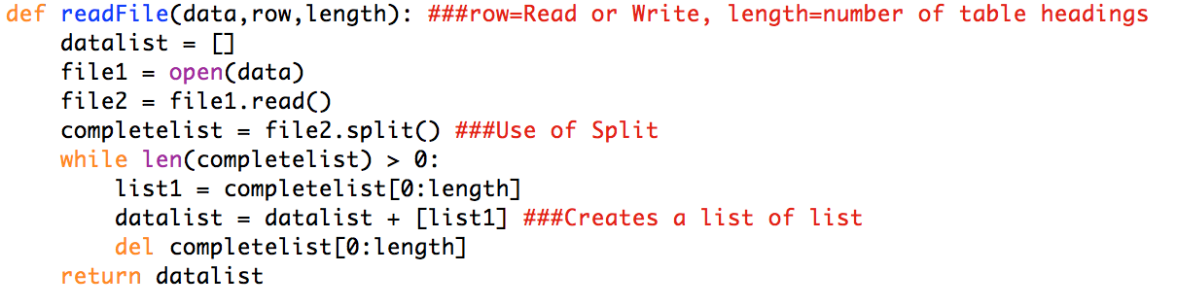

Exercise 2:

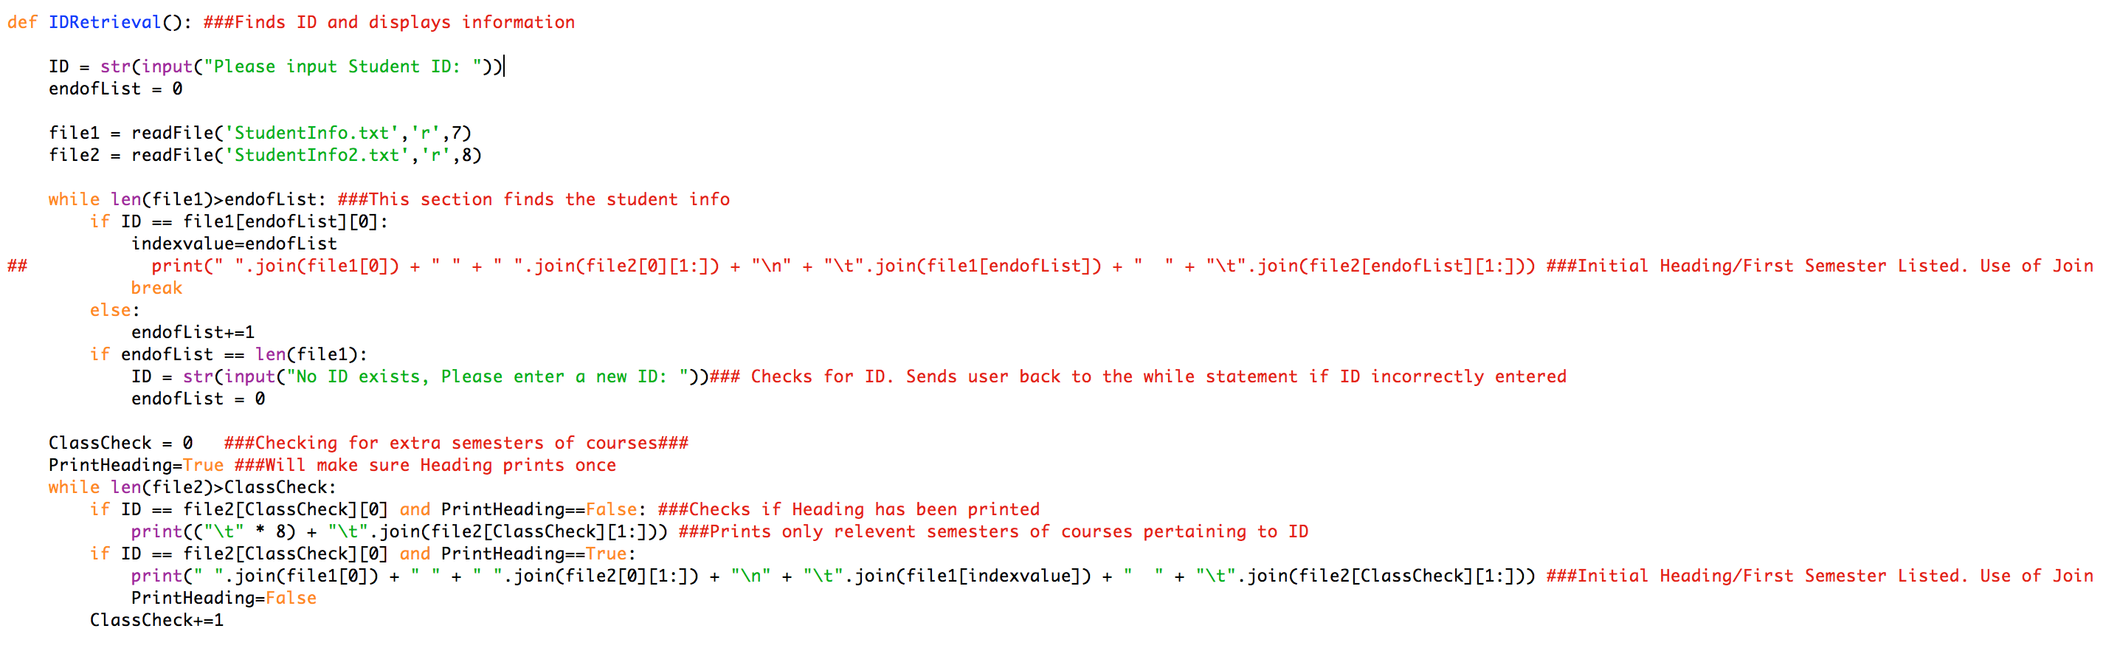

Exercise 3:

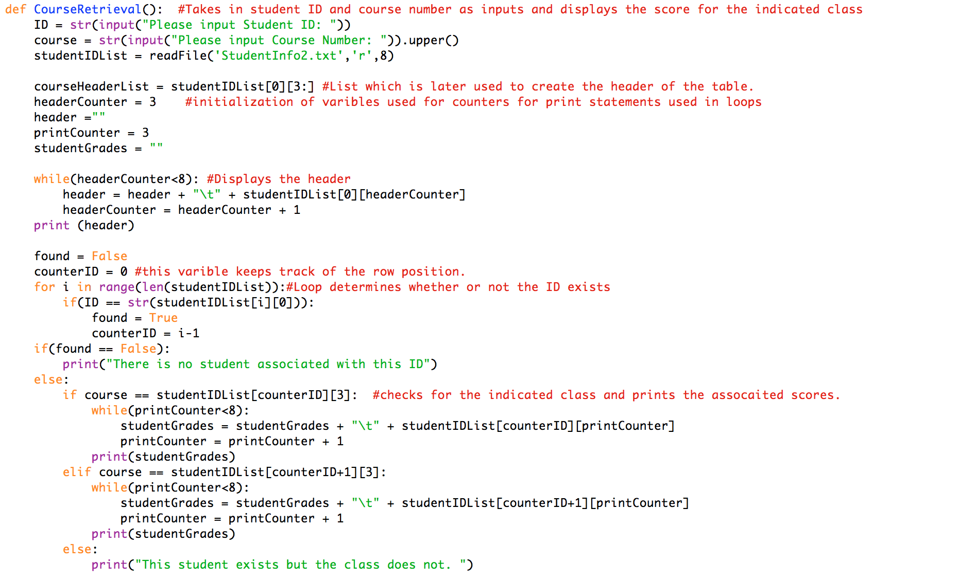

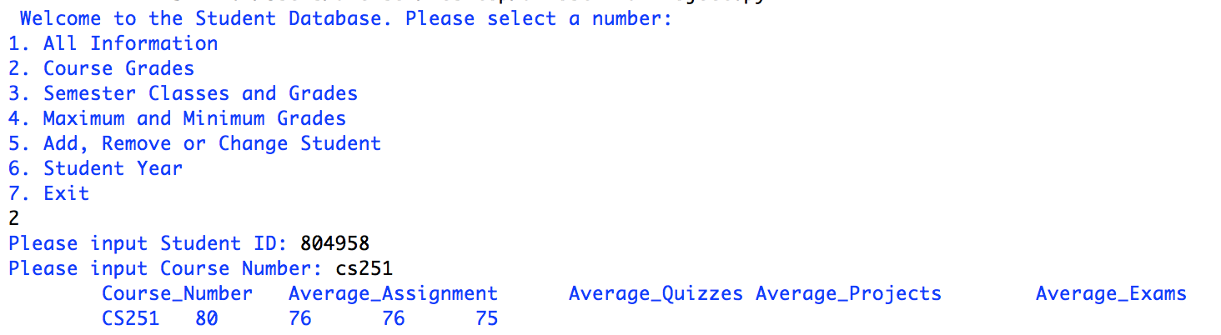

Exercise 4:

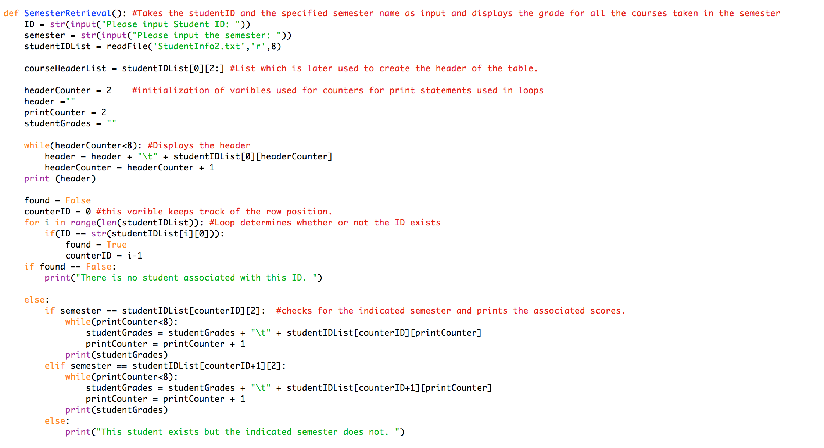

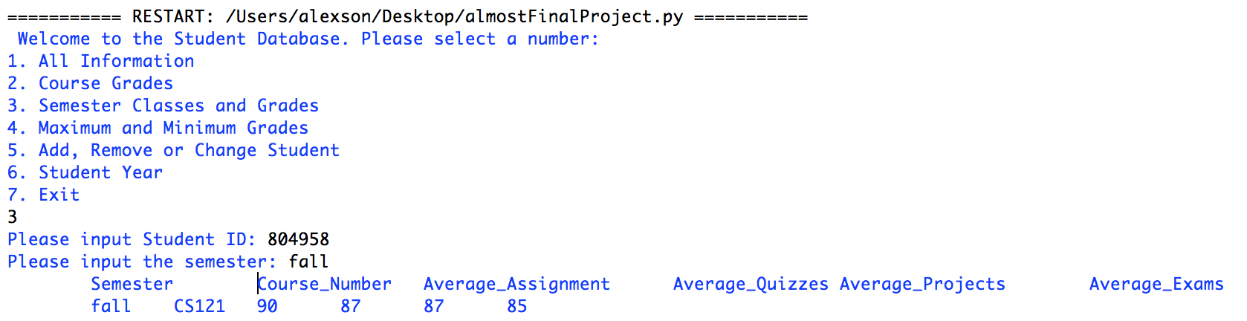

Exercise 5:

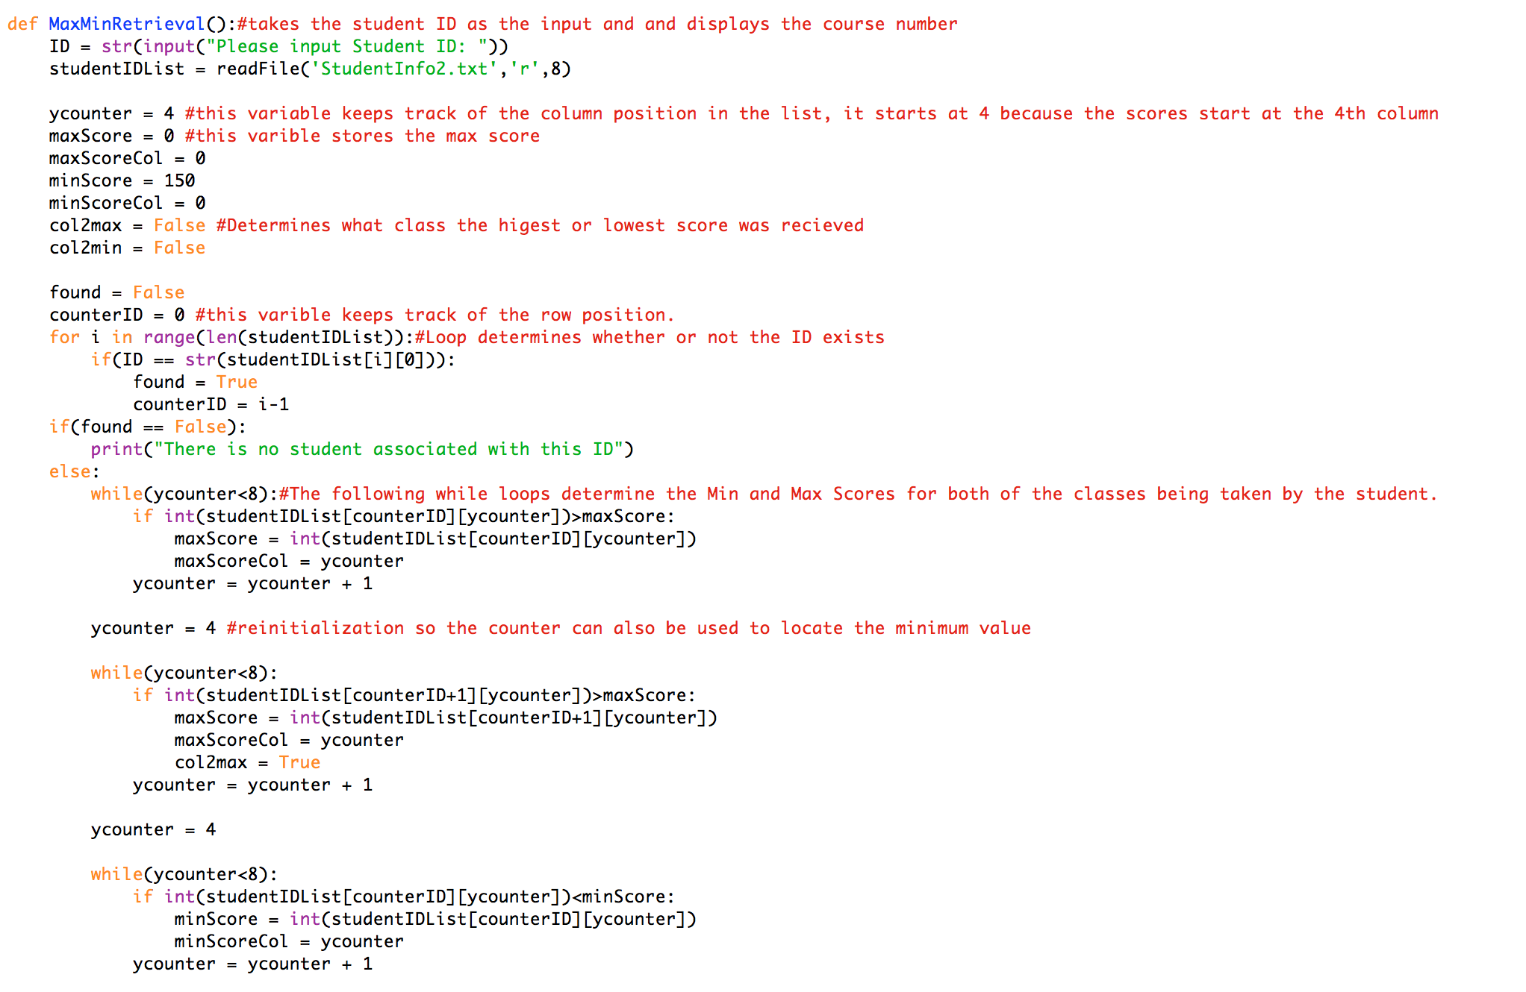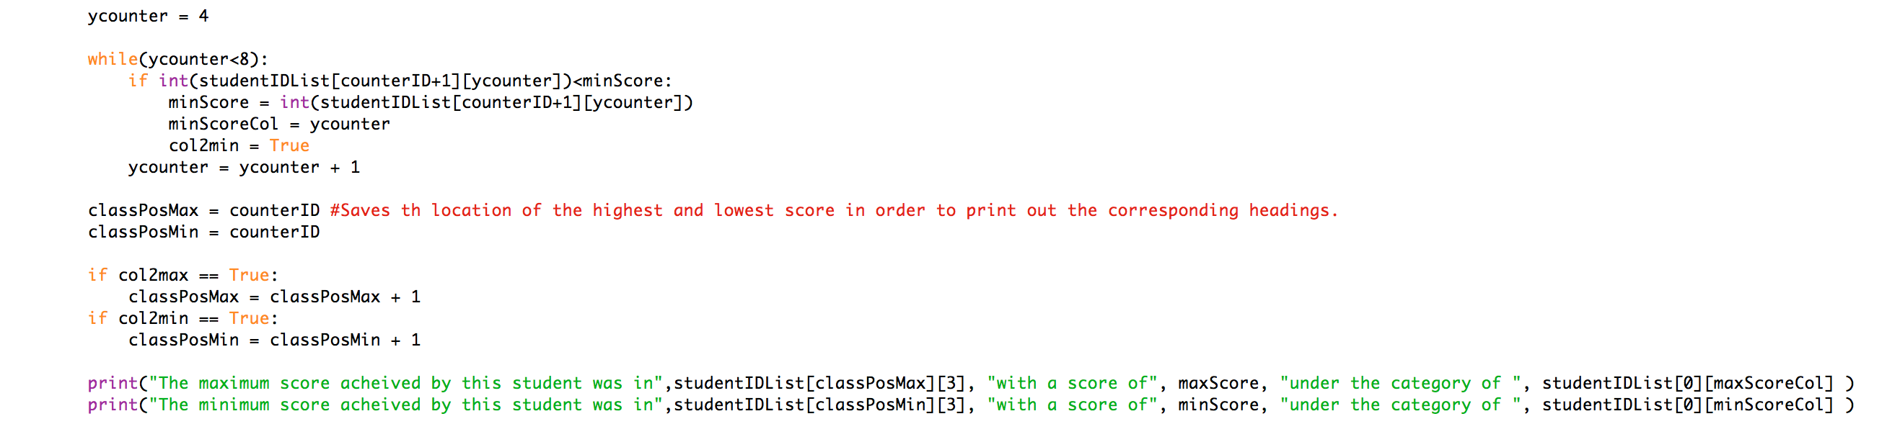

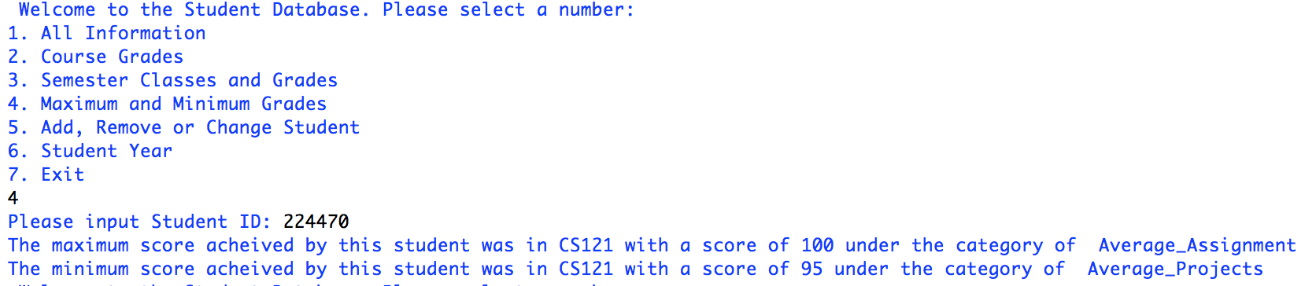

Exercise 6:

/Users/alexson/Desktop/Screen Shot 2016-10-20 at 11.35.18 PM.png/Users/alexson/Desktop/Screen Shot 2016-10-20 at 11.36.11 PM.png

Exercise 7:

Exercise 8:

Exercise 9:

Exercise 10: